MBA 881 - Starship Enterprise Folding Instructions

Please read and practice making planes prior to class!
A
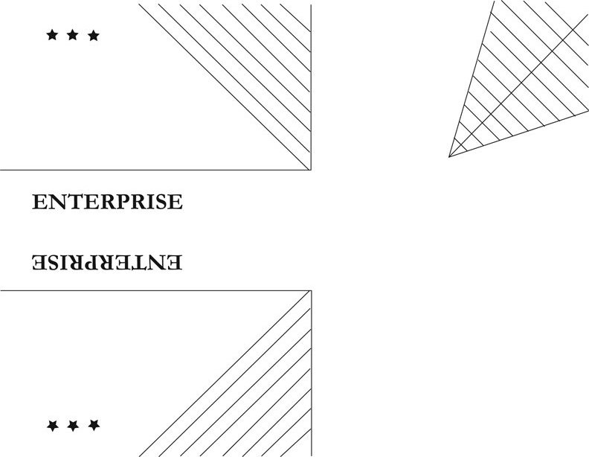
1.
3.
2.

B
“ENTERPRISE” lettering
on back

4.
4a.
3a.
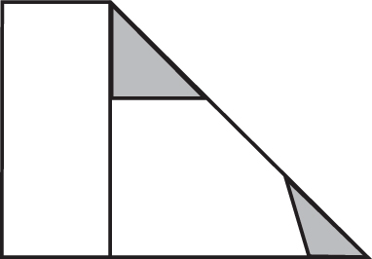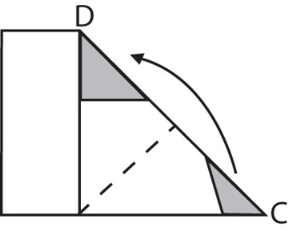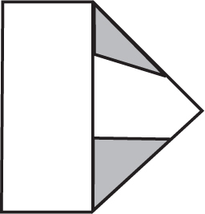

6.
5a.
5.
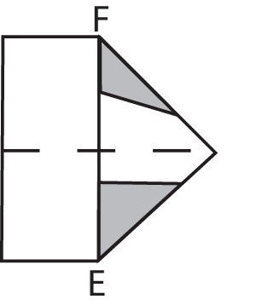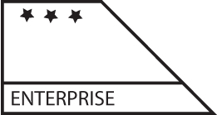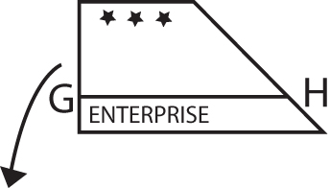
6a.
7a.
7.

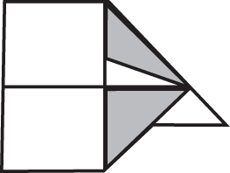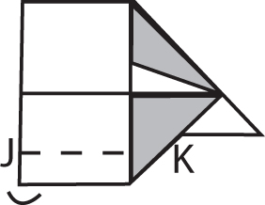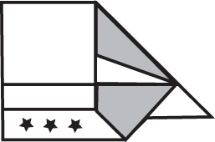

9.
8a.
8.

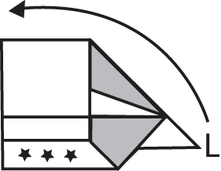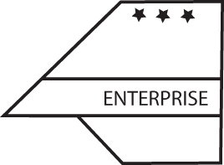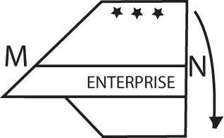

10a.
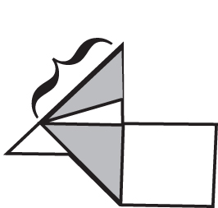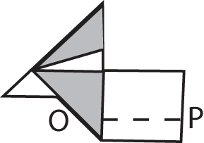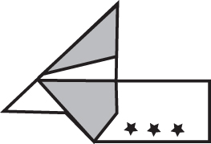
9a.
10.

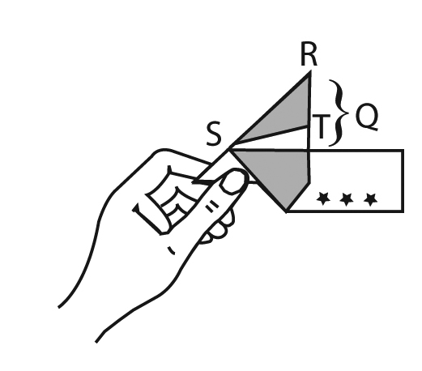
11a.
11b.
11c&d.
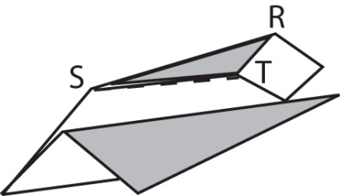
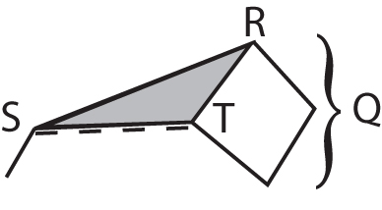

12. Finished planes should look like this:

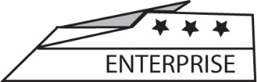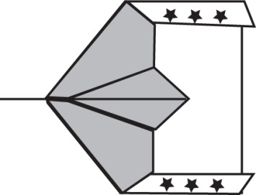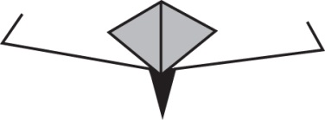

Side View Top View Front View (note wing deck should be flat and the wing tips are straight up)

Starship Enterprise Folding Instructions - Continued

1. You should have a piece of paper that has one blank side, and one side that looks like this.

2. Turn the paper over so that the blank side is facing up and the word “ENTERPRISE” is on the left-hand underneath side. 2a. It should now look like this.

3. Fold corner A to B at the bottom of the paper. 3a. It should now look like this.

4. Fold corner C and D. 4a. It should now look like this.

5. Fold E to F. 5a. It should now look like this.

6. Fold on GH by starting with the part with the stars (* * *) on it and folding down so that the fold comes along the printed solid line. There are three thicknesses of paper – make sure you only fold the first layer. 6a. It should now look like this.

7. Make a fold (up direction) about 2.5 cm from the bottom along JK. 7a. It should now look like this.

8. Turn the Starship over and round so that L is on the left side. 8a. It should now look like this.

9. Fold on MN by starting with the part with the stars (* * *) on it and folding down so that the fold comes along the printed solid line. There are two thicknesses of paper – make sure you only fold the top one. 9a. It should now look like this. Make sure this sticks up in the centre.

10. Make a fold (up direction) 2.5 cm from the bottom along OP. 10a. It should now look like this.

11. Read all of Step 11 and then go back and do it step by step.
- Hold Starship in hand.
- Open up Q with finger and flatten the lines area by bringing central point R toward the
main body of the plane.
- Fold along ST to keep it flat.
- Make wings level and even with each other so that plane can fly.

The Six Government Purchase Criteria
- Printed lines should be in the position shown on the diagram.
- The wing tips must be turned up 2.5 cm on each wing and be straight up on both sides (not as shown above in Step 12 “Top View” and “Front View” which shows them incorrectly bending inwards).
- The “pilot’s cabin” (Step 11b) must be puffed out considerably (as shown above in Step 12 “Top View” and “Front View”) as skinny cabins crowd the fighter pilots. The cabin folds must be creased on the printed lines (as shown above in Step 12 “Top View” and “Front View”). The center cabin line must line up with the nose tip (as shown above in Step 12 “Top View”).
- The two wings must be level and even with each other (not as shown above in Step 12 “Front View,” but rather the entire wing deck should be even and at the same level). The printed lines on the wings must meet in the center at a 45° angle.
- The plane’s nose tip should be pointed at a 45° angle (as shown in Step 12 “Side View”).
- The planes should be able to fly (more or less ).

Government Purchasing Agents will only buy planes that meet
all Six Government Purchase Criteria.

The folding instructions and the plane template are adapted from Kolb, D. A., Rubin, I.M., & Osland, J. M. (1990). Organizational Behaviour: An Experiential Approach (2nd ed). Reproduced with permission.

