Vehicle Build with Shape Auction: Strategic Factor Markets

Brent McKnight (bmcknight@mcmaster.ca),

Associate Professor of Strategic Management at McMaster University

This exercise is similar to the egg drop auction in that it focuses on strategic factor markets and creativity in value creation activities. It has significant advantages in that it can be adapted for online or hybrid teaching and it is more streamlined.
Through this exercise teams of students will construct an image of a vehicle in PowerPoint from collections of shapes acquired through an auction with their peers. With a limited set of shapes, shapes that are easy to visualize as part of a vehicle (e.g., circles for wheels) become very expensive while items that are harder to imagine a use for (e.g. triangles) are cheap. Profit is determined by 1) price assigned by the professor as a judge (ranking) and 2) having the lowest cost function. This simulation demonstrates Barney’s (1986) notion of superior expectations in strategic factor markets.
Vehicles are restricted to land or water bound transports because building spaceships and flying machines turned out to be exceedingly simple. Symmetry of any kind makes for a great spaceship!!

Preparation
To prepare for the simulation, you need to decide on resource munificence. In this simulation, that means how many “lots” or “collections” of shapes you have on offer. In a class with 6 teams I have used 16 “lots” of shapes and with 8 I have used 19 “lots”. This is the level of resource munificence in their world and is fair game for experimentation. The fewer shapes, the more challenging the task.
Put these files up on your learning management system for students to download. It is these PowerPoint slides that students will use to construct their vehicles.

Running the Simulation

Step 1: Team Instructions (10 minutes).

Assign students to groups of 4-6. Explain the task to the students including:
- A story. I typically put a silly story such as the professor has just finished class but needs to get home. He has no vehicle! Your task is to build him a vehicle (driving, rails, floating). I add that the professor gets airsick, so nothing that flies.
- Incentive. In my class, I give a 5% bump on in-person participation for the winning team to create incentive.
- Process. I explain the process and how much time for each stage – planning (10 minutes), bidding (15 minutes if done efficiently), construction (12 minutes), delivery and explanation (a few minutes to collate), and then judging (often I do that with my TA over a break – announcing the winner when they return).
- Rules. The winning team is based on the difference between price assigned by the judges and the costs accrued in the auction process.
  - I explain that price is determined by judge’s ranking which is based on appearance and functionality (it looks most like a vehicle). The top ranked team receives a $100 price with $8 taken off for each ranking. So the 3rd place team receives $84. Note, I found that the penalty must be high enough because some groups will create horrible vehicles but still win unless the last place price is sufficiently low.
  - Costs are the total of what is paid to acquire shapes.
  - It is important students know how they can manipulate shapes. I explain that they can rotate, flip, and colour shapes however they want. They cannot resize and they cannot duplicate shapes. They also need not use all the shapes they have purchased.
  - I do not permit students to sell shapes to other teams. Although this could bring in interesting dynamics, it also I think muddies the waters as to what is going on in the simulation.

Step 2: Planning (10 minutes).
Students have 10 minutes to plan their approach including thinking about the vehicle they will build and their bidding strategy. This is important because it allows groups time to devise a plan and then place a value on a “lot” of shapes that will help them meet their goals.
In a Zoom setting, this would be done in breakout rooms. I have had success with this in a simultaneous hybrid situation as well with students working with team members offsite. In this situation, one in-person student would connect to Zoom and join the breakout room that houses their colleagues.

Step 3: Auction (10-15 minutes).
Since students will have time to look at the “lots” of shapes in the planning phase, the auction can start right away after planning. Auction each lot off in order. I use a rising price auction.
Groups have $100 to spend and bids are made in increments of $5. Remember, the more they spend, the higher their costs to determine price and the winning team.
This can be lots of fun. Be faced paced and don’t give too much time for each lot. Students use lots of different strategies in their bidding, often bidding up competing teams.
Record the prices on a spreadsheet. I use one that automatically sums up what each group spends.

Step 4: Build and submit vehicles.
Students have 12 minutes to construct their vehicle in PowerPoint. To do so, they download the PowerPoint with the different “lots” of shapes and extract the slides they have purchased.
Once the time is up, I ask that they email their shape to myself (and an in-class TA if applicable). I give each group an opportunity to tell a story about their vehicle. This can be a lot of fun as students make up stories about their vehicles and the choices they made.
There are different ways to manage this logistically. If virtual, groups can just share their screen and display their image. This works in person as well if there is a Zoom link for the class, or the professor/TA can collate the images into a single PowerPoint slide for presentation.
See some examples of vehicles students have built at the end.

Debrief:
I tend to emphasize two key points in my debrief of the vehicle design simulation: identification of valuable resources and equifinality of paths to competitive advantage.
First, I explain that obviously valuable resources are often coming with a higher price tag and that this reduces their contribution to competitive advantage. I often work to get the students to identify this insight. I ask questions like “Why did you spend so much on this item?” Or ask them if they had a back-up plan? Or to a team that spent very little, I ask them “How did you get away with spending so little?” These conversations often elucidate how difficult it is to create value by acquiring resources on the open market and alternatives to doing so.
I ask then what conditions would need to be present for companies to buy resources at a price that would permit them to be profitable? We get to realizing that it is likely one of three things:
- The company has complementary capabilities that allows them to use the resources in a way that other companies would not be able to.
- An asymmetry of market information that benefits the resource acquiring firm
- A rare opportunity, such as being in the right place at the right time.
Second, I talk about equifinality. This means that firms may take different paths to still create valuable, rare and costly to imitate resources.

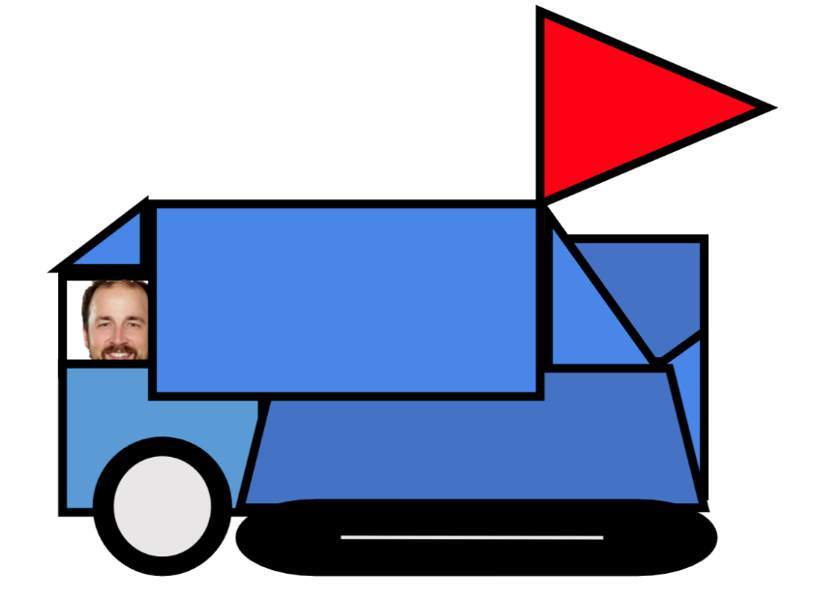
Examples of Vehicles


